Concurrent Programming Fundamentals, Implementing

synchronization, Message Passing - Background and

Motivation, Multi threaded programs, Communication

and Synchronization, Language and Libraries, Thread

creation Syntax

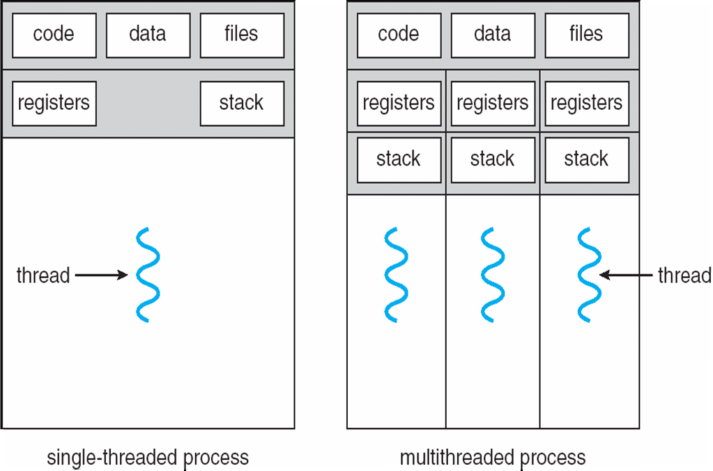

e major differences between shared memory and message passing model −

| **Shared Memory** | **Message Passing** |
| --- | --- |
| It is one of the region for data communication | Mainly the message passing is used for communication. |
| It is used for communication between single processor and multiprocessor systems where the processes that are to be communicated present on the same machine and they are sharing common address space. | It is used in distributed environments where the communicating processes are present on remote machines which are connected with the help of a network. |
| The shared memory code that has to be read or write the data that should be written explicitly by the application programmer. | Here no code is required because the message passing facility provides a mechanism for communication and synchronization of actions that are performed by the communicating processes. |
| It is going to provide a maximum speed of computations because the communication is done with the help of shared memory so system calls are used to establish the shared memory. | Message passing is a time consuming process because it is implemented through kernel (system calls). |
| In shared memory make sure that the processes are not writing to the same location simultaneously. | Message passing is useful for sharing small amounts of data so that conflicts need not occur. |
| It follows a faster communication strategy when compared to message passing technique. | In message passing the communication is slower when compared to shared memory technique. |
| Given below is the structure of shared memory system − | Given below is the structure of message passing system − |